**Bahria University**

**Karachi Campus**



**COURSE: SEL-221 SDA LAB**

**TERM: SPRING 2023, CLASS: BSE- 4 (B)**

**Project Report**

**LIBRARY MANAGEMENT SYSTEM**

**Submitted By:**

**M Jahanzaib 02-131212-036**

**(Name) (Reg. No.)**

**Abdul Muqeet 02-131202-085**

**(Name) (Reg. No.)**

**AHMED AYAZ 02-131202-051**

**(Name) (Reg. No.)**

**Submitted To:**

**Engr. M Rehan Baig**

**Signed Remarks: Score:**

**TABLE OF CONTENTS**

|  |  |  |
| --- | --- | --- |
| **S No** | **Topics** | **Page No.** |
| 1. | Background | 3 |
| 2. | Introduction | 3 |
| 3. | Project Paradigm | 3 |
| 4. | Mechanism and working | 3 - 4 |
| 5. | Hardware Interfaces | 4 |
| 6. | Software Interfaces | 4 |
| 7. | Remaining Code Module and API Platforms | 5 - 7 |
| 8. | Project Modules | 8 - 9 |
| 9. | Conclusion | 9 |
| 10. | Reference | 9 |
|  |  |  |
|  |  |  |
|  |  |  |
|  |  |  |
|  |  |  |
|  |  |  |
|  |  |  |
|  |  |  |

**Background:-**

Design patterns are programming language independent strategies for solving a common problem. That means a design pattern represents an idea, not a particular implementation. By using design patterns, you can make your code more flexible, reusable, and maintainable.

It’s not mandatory to always implement design patterns in your project. Design patterns are not meant for project development. Design patterns are meant for common problem-solving. Whenever there is a need, you have to implement a suitable pattern to avoid such problems in the future. To find out which pattern to use, you just have to try to understand the design patterns and their purposes. Only by doing that, you will be able to pick the right one.

**Introduction:-**

Our project “Library Management System” is using Design pattern Singleton on all the entities that are suppose to be single. Those are Admin, Student, Faculty and Librarian. This project is about Library Management System which is used to manage all the activities that comes under the area of a management system. This project is developed by using different tools like SQL Management Studio. It also includes a user-Friendly interface implemented by using c language and windows form. The connections are made by using Connection Strings. This project includes all the required functionalities to implement this management System. This system mainly focuses on basic operations in a library like adding new books, and updating new information, searching books and members and return books. This project of “LIBRARY MANAGEMENT” of gives us the complete information about the library. This project is implemented by using the concepts of Design pattern that we have studied in lab so far.

**Project Paradigm:-**

In software engineering, the singleton pattern is a software design pattern that restricts the instantiation of a class to one "single" instance. This is useful when exactly one object is needed to coordinate actions across the system. The term comes from the mathematical concept of a singleton.

**Mechanism and Working:-**

***Mechanism:-***

An Architectural Style is the application design at the highest level of abstraction; An Architectural Pattern is a way to implement an Architectural Style; A Design Pattern is a way to solve a localized problem.

***Working:-***

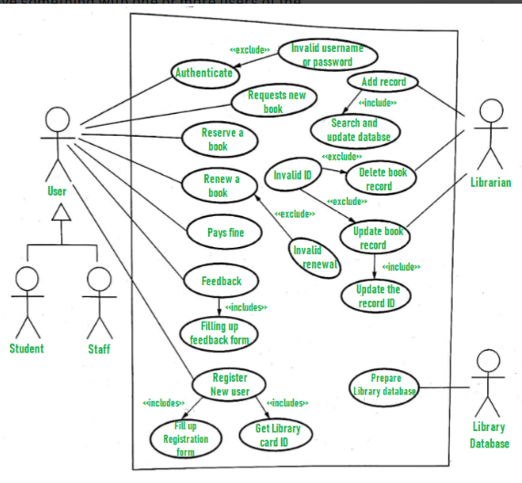

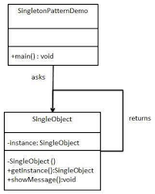

**Hardware Interfaces:-**

In this project no such hardware interface is used.

**Software Interfaces:-**

It is developed by using windows form C# Application.

**Remaining Code Modules APIS And Platforms:-**

**OUTPUT:-**

**project MODULES:-**

**LOG IN Module:-**

**Librarian Rights Module:-**

<Generate report , BookIssue , AddPenaulty>

**Student Rights Module:-**

<BookIssue,SeeProfile,UpdateData>

**Faculty Rights Module:-**

<BookIssue,SeeProfile,UpdateData>

**Admin Rights Module:-**

<Add, delete, read,remove books>

<Add, delete, read,remove Students>

<Add New Student, Faculty,Librarian,Admin>

Singleton is applied in all the entities which are suppose to be one.

**Conclusion:-**

Design patterns provide a common vocabulary for designers to use to communicate, document,and explore design alternatives. Design patterns make a system seem less complex by letting you talk about it at a higher level ofabstraction than that of a design notation or programming language.**s**

**References:-**

[**https://herbertograca.com/2017/07/28/architectural-styles-vs-architectural-patterns-vs-design-patterns/#:~:text=An%20Architectural%20Style%20is%20the,to%20solve%20a%20localised%20problem**](https://herbertograca.com/2017/07/28/architectural-styles-vs-architectural-patterns-vs-design-patterns/#:~:text=An%20Architectural%20Style%20is%20the,to%20solve%20a%20localised%20problem)**.**

[**https://en.wikipedia.org/wiki/Singleton_pattern#:~:text=In%20software%20engineering%2C%20the%20singleton,mathematical%20concept%20of%20a%20singleton**](https://en.wikipedia.org/wiki/Singleton_pattern#:~:text=In%20software%20engineering%2C%20the%20singleton,mathematical%20concept%20of%20a%20singleton)**.**

[**https://en.wikipedia.org/wiki/Architectural_pattern**](https://en.wikipedia.org/wiki/Architectural_pattern)

**https://riccentre.ca/software-architecture-design-patterns/**

**THE END**